First solar hydrogen storage in a private building in Western Switzerland : building energy analysis and schematic design

TECPHY, Cleantech and building consulting
www.tecphy.ch

Author : Philippe Couty
Date : 29.01.2019
Submitted to CISBAT 2019 conference https://cisbat.epfl.ch/

Keywords : Energy analysis, PV, self-sufficiency, seasonal storage system, decentralized energy, Solar hydrogen storage, hydrogen electrolysis, fuel cell, electric mobility, swimming pool, Polysun

Engineering Services:
- Building energy and building systems
- Polysun Simulations
- Schematic design solar hydrogen storage
- Development design
- Purchasing equipment’s
- Installation and commissioning
- Acceptance tests
- Building systems optimization and monitoring

Solar Hydrogen for buildings
Buildings have a great potential to produce their own electricity thanks to affordable photovoltaics and available area roofs and facades. To be self-sufficient over the year, the electricity converted to hydrogen by electrolysis during the sunny season can be re-used with the help of fuel cells during the winter season. Self-sufficiency of the building as well as a drastic carbon emission reduction can be obtained thanks to the introduction of PV systems coupled with Hydrogen seasonal storage. For Solar Hydrogen project, a schematic design phase is mandatory : dimensioning of the PV and storage systems, suggestion of reliable technologies available on the market, needed infrastructures and security. In this article, we introduce the case study of the first private building that will be equipped with solar hydrogen storage in western Switzerland. Dimensioning is performed with the help of the Polysun Simulation software and specific add-in modules in python.

First installation in western Switzerland
In this article, we introduce the case study of the first private building that will be equipped with solar hydrogen storage in western Switzerland. We list the steps of the schematic phase with the dimensioning methodology of a solar PV hydrogen-electrochemical system for a self-consuming building with a self-sufficient swimming pool. This concrete project also demonstrates the potential of deployment of solar hydrogen in the building market from single family homes to multi-storey buildings. The project is currently in the project phase, the PV and complete solar hydrogen system are in the purchasing phase.

The aim of the project was to maximize the self-sufficiency of an architectural building with SRE 1200 m2 and 60’000 kWh electrical energy needs. In this project we have also a swimming pool that will be used over the whole year and which must be only heated by renewables. This will be achieved by installing solar PV on roof and facades, electrochemical batteries and solar hydrogen storage. Solar Thermal is also installed.
The first main step is the global building energy analysis of the building. Heating needs are calculated and dynamic simulations of the whole building systems including PV and hydrogen storage are performed with the help of Polysun Software (see Figure 1) as well as post treatment programs. The consumption will depend on building characteristics and building systems (envelop quality, HVAC heat pump geothermal, domestic hot water, appliances) and on the program usage of the owner with corresponding consumption profiles. Special programs have been developed to calculate heat losses of the swimming pool during the wintertime that can be taken into account in the Polysun model. Electrical Mobility can be introduced in the model as an additional consumer and will be part of the activity scenarios of the building.
For the dimensioning of system’s power in kW (PV, charger-inverters, electrochemical batteries, electrolyser and fuel cell) as well as the electrical storage capacity in kWh, hourly simulation must be performed. The buildings is considered as consumers and producers that can exchange energy in real time within a grid network. Note that Hydrogen systems are hybrid systems always comprising an electrochemical battery absorbing fast changes and a fuel cell to manage longer run energy needs. The daily self-consumption is obtained with the help of the electrochemical storage, and the seasonal self-consumption is provided by the solar Hydrogen storage. Specific program modules are used for this task, see illustration Figure 2.
As a final result of the schematic design phase, the environmental indicators GWP, CED and CEDnr, including PV systems and storage systems are calculated [2]. PV technologies, type electrochemical batteries, production, life time and number of cycles are considered in the calculations. Indicators can be compared with the scenario situation without Solar Hydrogen where energy is taken from the grid and where vehicles use fossile energy. The economic analysis as well as the environmental gain should be done in this early phase to help the decision makers to go ahead with the project phase.

Schematic design phase summery
The approach for the schematic design of solar hydrogen system toward a self-sufficient building is the following :

Phase 1 : Global energy analysis of the building: production - consumption - storage
- Calculate the electrical consumption of the building by calculating heat needs and modeling the entire building systems and consumption profile with the help of Polysun software.
- Identify potential production surfaces for PV and identify suitable BIPV products with the architect
- Calculate the monthly energy balance to determine the overall storage potential and relevance.
Phase 2 : Hourly simulations of the complete building with PV and storage systems
- Modelise the building systems as well as the PV solar hydrogen –electrochemical system.
- Perform hourly simulations of the electrical flux between PV, consumers, electrochemical and hydrogen storage and the public grid.
- Calculate the number of storage cycles and grid import/export as a function of storage capacities, installed powers and storage strategies.
- Dimensioning the system optimum powers and capacities which minimize grid import with a minimum investment cost for the owner.
- Calculate the environmental impacts gains.

Results and illustrations
This first installation in western Switzerland will open the road of affordable solar hydrogen systems for private building owners which until now was reserved to the industrial market. Thanks to an integrated design with multi-oriented façades and flat roof, the potential of available surface for PV production has been maximized for this architectural building with 8 kWp on roof and 10 kWp on facades. The optimum capacity of the electrical storage has been calculated: 35 kWh capacity and 1000 kWh solar hydrogen storage. 100% self-consumption, 100% self-sufficiency of the swimming pool and 30% self-sufficiency of the building are expected. With the presented approach, 100% self-sufficient building could be easily designed with other building typologies with higher PV installed power.
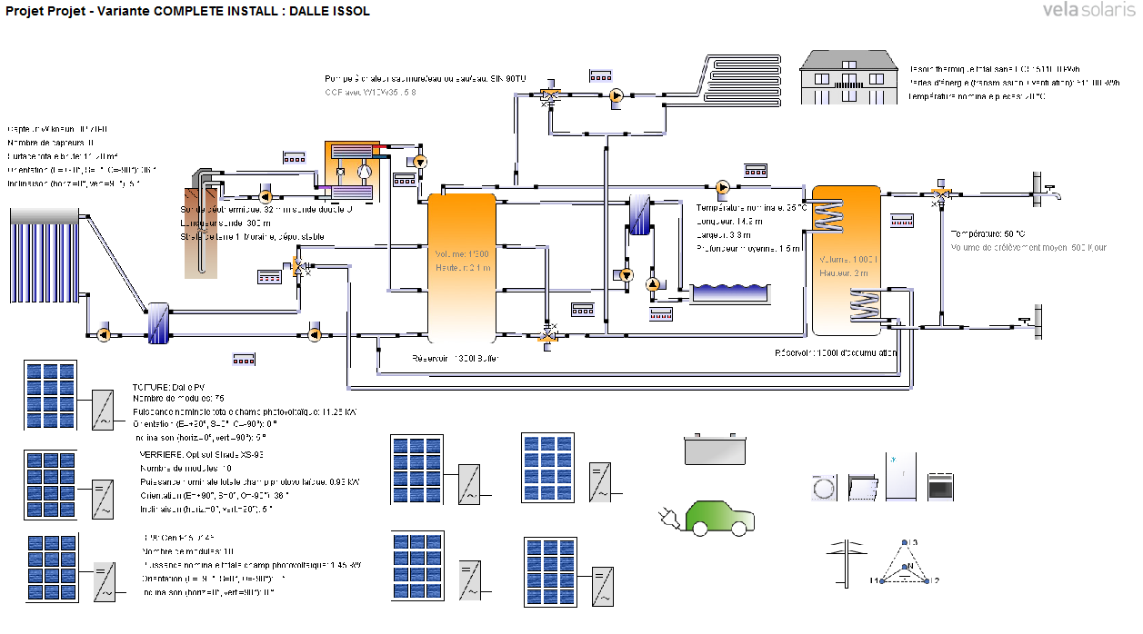
Figure 1 : Building system simulations with PV production on roof and facades. Building energy analysis is performed with the help of Polysun software and add-in modules.
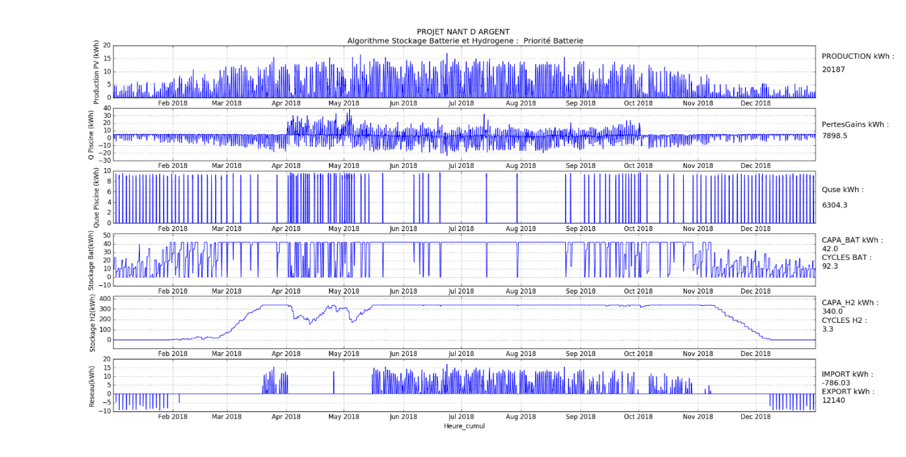
Figure 2 : Hourly simulation of a multi-storey building, python programing of Hydrogen storage systems coupled with PV : production and consumption powers, state of charge electro-chemical battery and Hydrogen storage level, Grid import and export powers.

TECPHY: your partner for Solar Hydrogen and Renewable Energy
Tecphy was founded in 2018 by Philippe Couty. It is an individual company of consultancy for the industry and the building sector developing cleantech technologies. Philippe Couty started a PhD in 1997 at EPFL in the field of cavitation in hydraulic turbines, after a master degree in physics and fluids mechanics. In 2004, he Co-founded Karmic Sarl and developed micro and nanotechnologies applications. He then decided to join the photovoltaic adventure in 2007 with the company Flexcell VHF-technologies, with mission to increase cell’s efficiency of flexible solar panels using nano structuration and laser technologies. Since 2013, he pursues a carrier in R&D and industrial developments in the field of energy and industrial technologies. Between 2015 and 2017, he lead the engineering of the Swiss living challenge who won the DOE Solar Decathlon competition US 2017 Denver Colorado [1][3][4].

References

[1] P. Couty , M.J. Lalou, P. Cuony, S. Cotture, V. Saade, Positive energy building with PV facade production and electrical storage designed by the Swiss team for the U.S. Department of Energy Solar Decathlon competition 2017 Denver, Colorado, Conf CISBAT 2017, Energy Procedia 122 (2017), 919–924
[2] Integrating hourly life-cycle energy and carbon emissions of energy supply in buildings
Sustainable Cities and Society, Volume 43, November 2018, Pages 305-316
[3] “La maison du future est Suisse” http://www.efficience21.ch/magOnline.php?mag=59924
[4] “Avec le soleil comme seule source d’énergie” http://www.bulletin.ch/fr/news-detail/avec-lesoleil-pour-seule-source-denergie.html

